**Understanding How Java Programs Get Executed: A Step-by-Step Guide**

**Execution of java programme**

In this article let’s together know briefly how a java program is executed starting from Compilation, Interpretation, and getting the output according to the Program Logic.

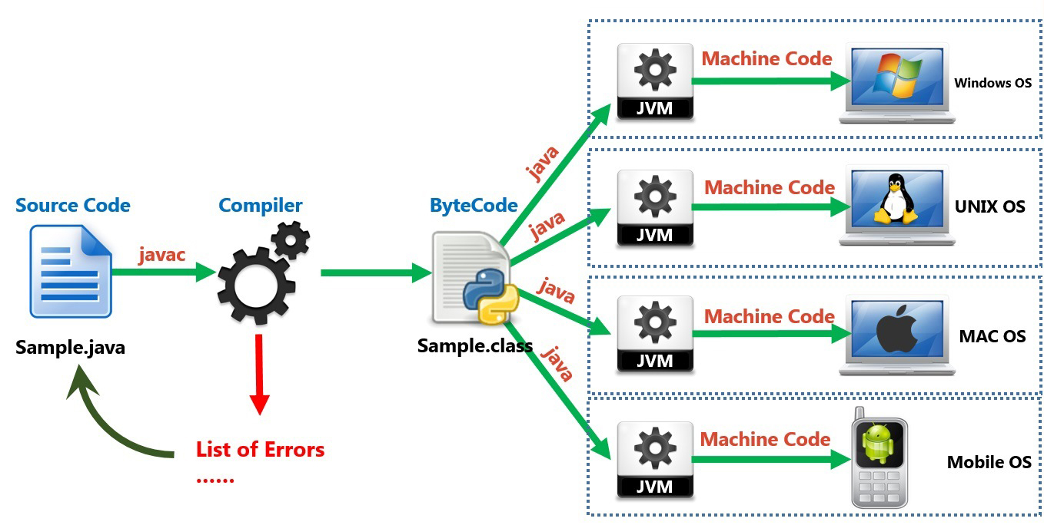

1. Writing a java code file

We know that Java Program is a high-level language written either in simple notepad or IDE (Integrated Development Environment) like Eclipse, or IntelliJ.

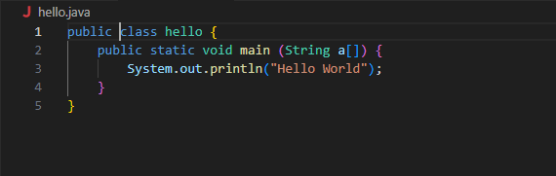

1. Once the code is written, it needs to be compiled. Java uses a **compiler** (called javac) to convert the source code (hello.java) into **bytecode**. This bytecode is saved in a file with a .class extension, (hello.class). The bytecode is a low-level set of instructions understood by the **Java Virtual Machine (JVM)**.

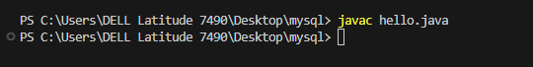

1. Class Loading

After the compilation, the JVM's **class loader** loads the .class file into memory. It also loads other required classes, including system libraries. This step sets up the necessary resources for executing the program.

1. Bytecode Verification

The JVM performs a process called **bytecode verification**, where it checks that the bytecode adheres to security and format standards

1. Execution the output

Once code is processed to the Interpreter it executes line by line and generates Machine code that is understandable by Computer, again here JIT(Just-In-Time) comes into the picture at the runtime to make the program execution faster.

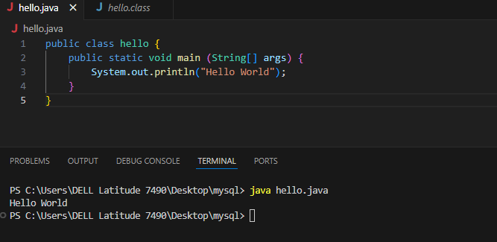

The generated Machine code is given as an input to the specific OS which runs and finally gives the Output on the console or any application GUI.

Role of JVM,JRE and JDK

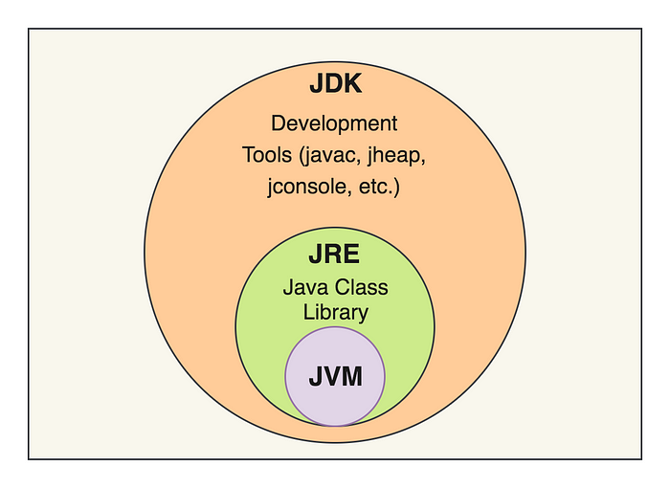

**JVM:**Java Virtual Machine loads the byte code, verifies it, and executes the code. It is specific to every operating system, but why java code is called to Write Once and Run Anywhere (WORA) because the byte code . As an example class file is compatible with running all OS with specific JVM.

**JRE:**Java Program needs to associate with required libraries to execute the program and guess what these libraries are part of JRE (Java Run Time Environment) which includes ClassLoader, Byte Code verifier, and many other libraries.

**JDK:**Java Development Kit,so we have written a java program but who is going to compile that and debug the code if we have errors in the code and the Javadoc for the methods and classes, so all these are embedded in the Java Development Kit.

Summary

Java program execution goes through several stages, starting from writing the code, compiling it to bytecode, and finally, the JVM executes it. Understanding this process helps in writing better, optimized code and knowing how Java's "write once, run anywhere" concept works.

Happy Learning !

References

<https://www.youtube.com/watch?v=GXUiEouK7DM>